Agouron Cruise # 2
PRR data Summary Mamoon Al-Rshaidat

- Station 198 (Green)
  - Station No. → 1
  - JD → 198
  - Date → 17 July 2006
  - Time → 18:27:19
  - DCM → 103.6 m @ 0.52% Light
  - 1% Light → 91.3 m
  - 0.14% Light → 126.7 m

  - Attenuation Coefficient (K_{z}) → -0.0453
  - Alpha → 271.75
  - R² → 0.9954
  - Average Surface PAR → 521.69 umol photon/m²/s

- Station 199B (Red)
  - Station No. → 10
  - JD → 199
  - Date → 18 July 2006
  - Time → 12:27:17
  - DCM → 75.2 m @ 2.1% Light
  - 1% Light → 85.1 m
  - 0.1% Light → 125.7 m

  - Attenuation Coefficient (K_{z}) → -0.051
  - Alpha → 1485
  - R² → 0.9858
  - Average Surface PAR → 1835.8 umol photon/m²/s

- Station 200B (Blue)
  - Station No. → 12
  - JD → 200
  - Date → 19 July 2006
  - Time → 16:40:04
  - DCM → 115.2 m @ 0.52% Light
  - 1% Light → 105.0 m
  - 0.1% Light → did not reach it

  - Attenuation Coefficient (K_{z}) → -0.0411
  - Alpha → 1303
  - R² → 0.9921
  - Average Surface PAR → 1752 umol photon/m²/s

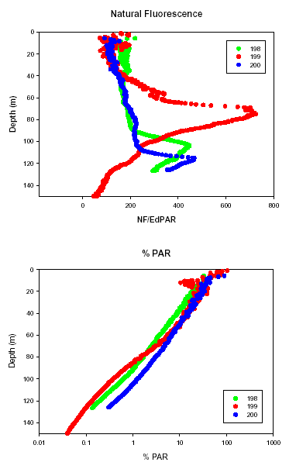
Cruise #1 from Angel:

Station/ Filename | Coefficient of Exponential fit | Depth of 1% light level on downcast [m] | Average Surface PAR during profile
AG1-1 | -0.041 | 106 | 2084
AG1-2 | -0.033 | 108 | 983
AG1-3 | -0.038 | 114 | 1673
AG1-5 | -0.039 | 98 | 549
AG1-6 | -0.034 | 113 | 1804
Average | -0.037 | 108

